**Assignment 8.1:**

**Problem Statement:**

* Get a list of employees who receive a salary less than 100, compared to their immediate employee with higher salary in the same unit

**Steps**:

🡪 Create Table “Emp_Sal”:

CREATE TABLE Emp_Sal

(

emp_id INT,

name STRING,

salary INT,

unit STRING

)

ROW FORMAT DELIMITED

FIELDS TERMINATED BY '\t';

🡪 Load table “Emp_Sal” with the given data set:

LOAD DATA LOCAL INPATH '/home/acadgild/hive/Emp_Sal.txt' OVERWRITE INTO TABLE Emp_Sal;

🡪Use below query to find employees who receive salary less than 100:

SELECT emp_id,name,salary,unit FROM Emp_Sal WHERE salary<100;

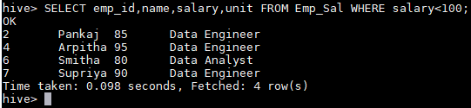

**Problem Statement:**

* List of all employees who draw higher salary than the average salary of that department.

**Steps:**

🡪Query to the above problem statement is:

hive> select e.*

> from (select e.*, avg(salary) over (partition by unit) as avgsalary

> from Emp_Sal e

> ) e

> where e.salary > e.avgsalary;

